GOVERNMENT DENTAL COLLEGE & HOSPITAL, KADAPA

DEPARTMENT OF PERIODONTOLOGY & IMPLANTOLOGY



SEMINAR PRESENTATION ON- “ DENTAL PLAQUE AS BIOFILM”

GUIDED BY: PRESENTED BY:

DR.P.SURESH, DR.K.LATHA,

PROF & HOD. 1ST YEAR PG.

**CONTENTS**

* **Introduction**
* **Definitions**
* **History**
* **Classification Of Dental Plaque**
* **Composition Of Dental Plaque**
* **Formation Of Dental Plaque**
* **Microbial Specificity Of Periodontal Disease**
* **Dental Plaque As Biofilm**
* **Characteristics of biofilm**
* **Methods To Detect Bacterial Plaque**
* **Conclusion**
* **References**

**INTRODUCTION**

* **Dental plaque –** A specific but highly variable structural entity consisting of microorganisms and their products embedded in highly organised intercellular matrix.
* It represents a true biofilm consisting of variety of microorganisms involved in wide range of physical, metabolic and molecular interactions.
* Biofilms have been implicated as chief culprit in the etiopathogenesis of dental caries and periodontal diseases.
* The term biofilm(wilderer and charaklis 1989) describes the relatively indefinable microbial community associated with a tooth surface or any other hard non shedding material, randomly distributed in a shaped matrix or glycocalyx.
* Teeth provide hard, non-shedding surfaces - accumulation & metabolism of bacteria on hard oral surfaces is considered the primary cause of dental caries, gingivitis, periodontitis and peri- implant infections.
* In the oral cavity, the bacterial deposits have been termed dental plaque or bacterial plaque.
* In 1-3mm of dental plaque weighing approximately 1mg, approx. 1011bacteria are present.

**DEFINITIONS**

* Dental plaque is defined clinically as a structured, resilient yellow-greyish substance that adheres tenaciously to the intraoral hard surfaces, including removable and fixed restorations – Carranza 11 edition.
* Bacterial aggregations on the teeth or other solid oral structures – lindhe,2003
* Plaque is a specific but highly variable structural entity resulting from colonization and growth of microorganisms on surfaces of teeth and consisting of numerous microbial species and stains embedded in a extracellular matrix- according to WHO 1978.
* Materia alba: Soft, whitish deposit with no specific architecture, which can be removed by water spray.

**HISTORY**

* J Leon Williams (1897) – Described dental plaque.
* GV Black (1899) – Coined term “gelatinous dental plaque”.
* W D Miller (1902) - Bacterial plaque.
* Wild (1941) -Shortened Black’s terminology to the term ‘Plaque’.
* Waerhaug (1950)- Described the importance of bacterial plaque in the etiology of periodontal disease.
* Loe et al (1965)- Landmark study on plaque , saying that plaque is main etiological agent in periodontal disease.
* Schei (1959), Russel (1967) - Epidemiological studies- Positive correlation between the amount of bacterial plaque and the severity of gingivitis.
* W.Loesche (1976) - Modern theories of specificity “Specific plaque hypothesis”
* Socransky 1979 - Modern Version of Specific Plaque Hypothesis
* PD Marsh & Martin (1999) - Ecological plaque hypothesis
* Costerton (1999) - Evolved Biofilm

**CLASSIFICATION OF DENTAL PLAQUE**

**SUPRA- GINGIVAL PLAQUE:**

* Supragingival plaque is found at or above the

gingival margin.

* Supragingival plaque in direct contact with the

gingival margin is referred to as marginal plaque.

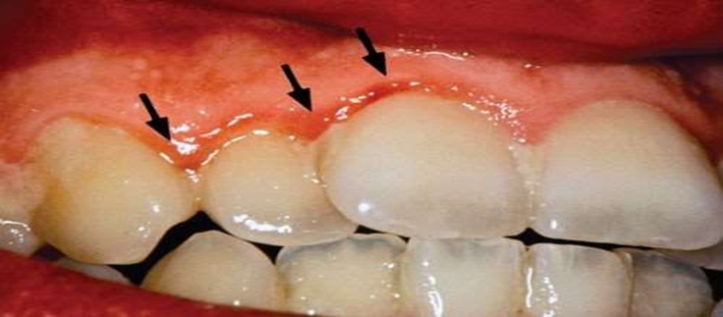

**SUBGINGIVAL PLAQUE**

* **found below the gingival margin, between the tooth and gingival sulcular tissue** 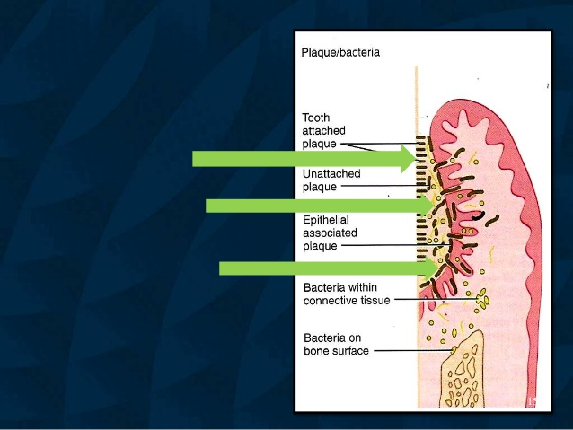

|  |  |  |
| --- | --- | --- |
| **Tooth attached** | **Un attached** | **Tissue attached** |
| **Gram +ve, Few Gram –ve rods and cocci** | **Gram negative rods, filaments, spirochetes** | **Gram negative rods, filaments, spirochetes** |
| **Does not extend to JE** | **Extend to JE** | **Extend to JE** |
| **Calculus formation, root caries** | **Gingivitis** | **Gingivitis,**  **periodontitis** |
| **May penetrate**  **cementum** | **-** | **May penetrate epithelium and connective tissue** |

**COMPOSITION OF DENTAL PLAQUE**

80% water 20% solids

65% extra cellular 35% bacteria

**INTERCELLULAR MATRIX:**

* Accounts for 20% to 30% of the plaque mass
* Organic and inorganic material..
* Derived from –Saliva , Gingival crevicular fluid and Bacterial products.

ORGANIC CONTENT – carbohydrates(30%)

proteins(30%)

lipids(15%)

INORGANIC CONTENT – calcium

phosphorous

sodium

fluoride

potassium & other minerals

Other minerals

**DEVELOPMENT OF DENTAL PLAQUE**

**FORMATION OF THE PELLICLE :**

1. Vigorous tooth brushing – nanoseconds – acquired pellicle .
2. Acquired pellicle - a homogenous, membranous, acellular film that covers the tooth surface and frequently form the interface between the tooth, the dental plaque and calculus.
3. A fully established pellicle - 30 min, within 24 hr- 0.8 µm in diameter.
4. Derived from components of saliva and crevicular fluid as well as bacterial and host tissue cell products and food debris.

Transmission electron micrograph (TEM) of the acquired pellicle on an enamel surface

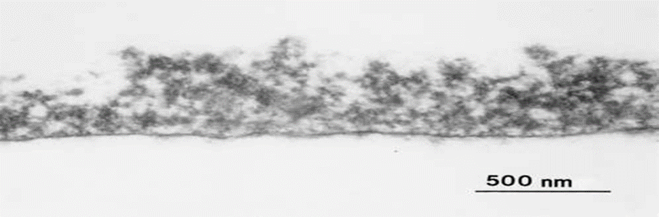

* Studies shows ( 2 hours) enamel pellicle, its amino acids composition differs from that of saliva, indicating that the pellicle forms by selective adsorption of the environmental macromolecules.

**SIGNIFICANCE OF PELLICLE**

* + NIDUS FOR BACTERIA -- Plaque formation by adherence Of microorganisms.
  + Lubrication prevent the surface from drying.
  + Provide protective barrier against acids thus may reduce dental caries attack.

**2. INITIAL ADHESION & ATTACHMENT OF BACTERIA:**

* We cannot conclude a single mechanism that dictates the adhesiveness of micro-organisms.
  + Transport to surface
  + Initial adhesion
  + Strong attachment

**PHASE I. TRANSPORT TO SURFACE**

* The first stage involves the initial transport of the bacterium to the tooth surface.
* Random contacts may occur
  + Brownian motion (average displacement of 40 µm/hour)
  + Sedimentation of microorganisms
  + Liquid flow
  + Active bacterial movement (chemotactic activity).

Schematic representation of different stages of formation of dental plaque

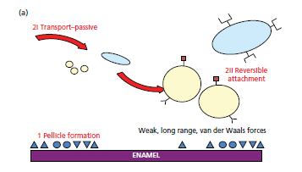

**PHASE II. INITIAL ADHESION:**

* Reversible adhesion of the bacterium and the surface
* Initiated by interactions b/w bacterium and surface through long range and short range forces, including
* Van der Waals attractive forces
* Electrostatic repulsive forces

**DLVO THEORY**

* Derjaguin, Landau, Verwey & Overbeek (DLVO) have postulated that Total Gibbs Energy (GTOT) is the sum of attractive forces and the electrostatic repulsion.
* At the physiologic ionic strength of saliva, vander waals forces results in net attraction of bacterial cells at a distance of 10 nm from the surface.
* Electrostatic repulsion prevents bacterial cells from getting closer to the surface.
* Stronger bonding at this point– interactions b/w Bacterial adhesions and receptors in the pellicle.

**PHASE III. Attachment**

* A firm anchorage between bacterium and surface will be established by specific interactions ( ionic, covalent, or hydrogen bonding).
* This follows direct contact or bridging true extra cellular filamentous appendages (with length up to 10nm).
* On a rough surface, bacteria are better protected against shear forces so that a change from reversible to irreversible binding occurs more easily and more frequently.
* The binding between bacteria and pellicle is mediated by specific extracellular proteinaceous components (adhesions) of the organism and complementary receptors (proteins, glycoproteins, polysaccharides) on the surface (pellicle) and is species specific.

**III. COLONIZATION AND PLAQUE MATURATION :**

**PRIMARY COLONIZERS**

* They provide new binding sites for adhesion by other oral bacteria.

The early colonizers (e.g., streptococci and Actinomyces species) use oxygen and lower the reduction-oxidation potential of the environment, which then favours the growth of anaerobic species.

**SECONDARY COLONIZERS**

* They do not initially colonize the clean tooth surface but adhere to bacteria already in the plaque mass.
* Including Prevotella intermedia , Prevotella loescheii, Fusobacterium nucleatum, and Porphyromonas gingivalis.

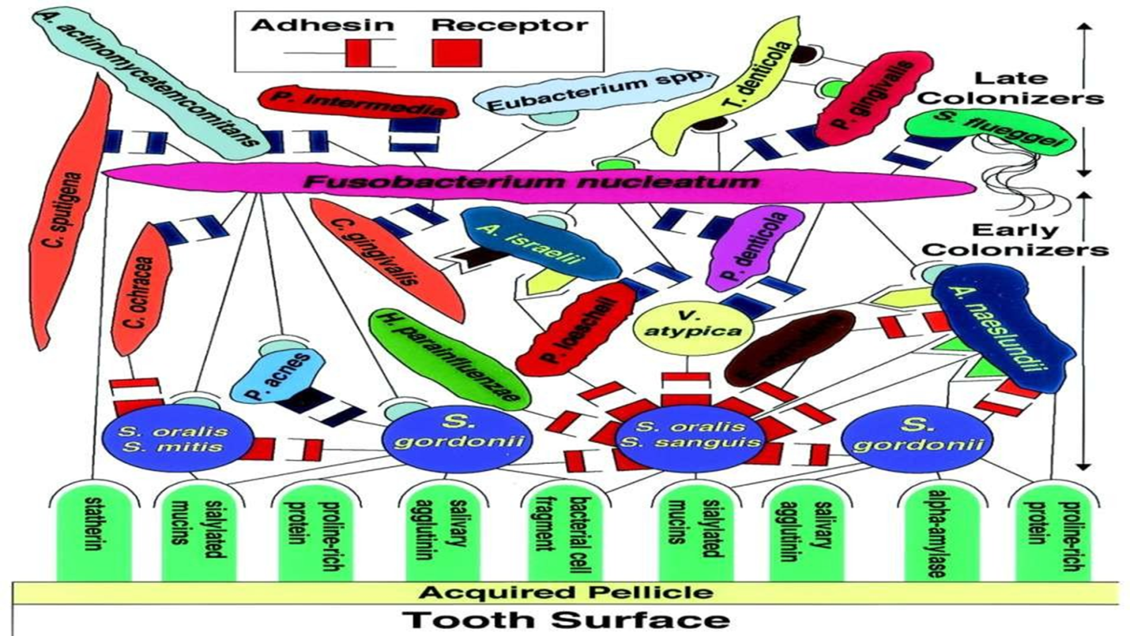

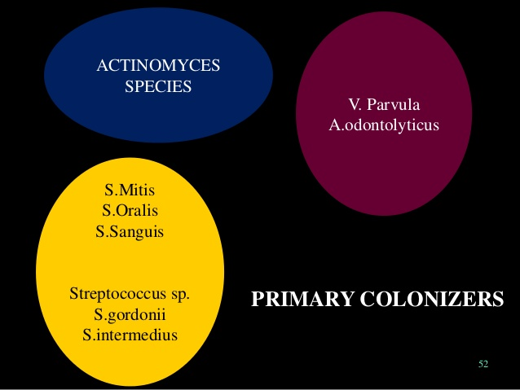 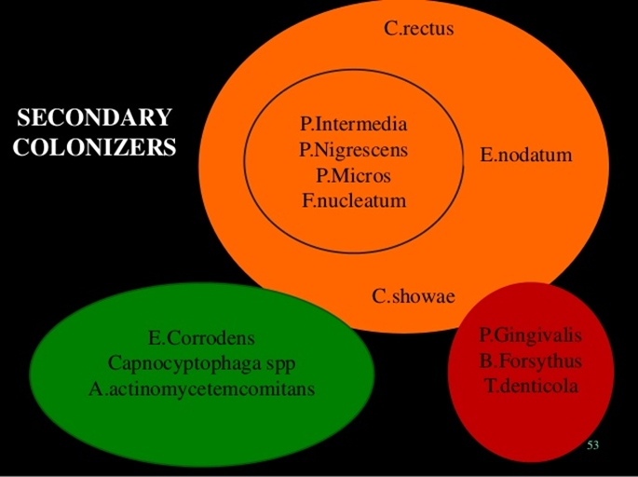

* Co-aggregation is the interaction between planktonic micro-organisms of a different strain or species.
* Co-adhesion is the interaction between a sessile, already adhering organism and planktonic micro-organisms of a different strain or species.

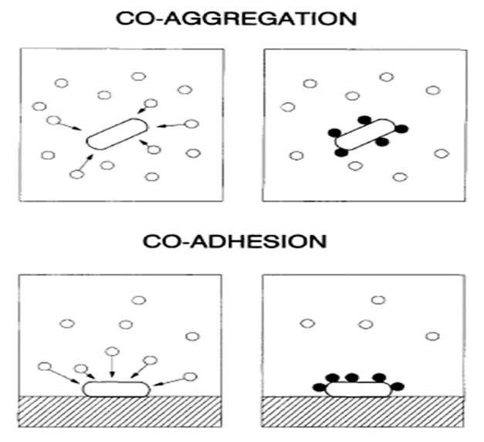

**Corncob” formation**

* Special example of co aggregation are corncob formation.

e.g. Streptococci adhere to the filaments of Corynebacterium matruchotti or Actinomyces spp.

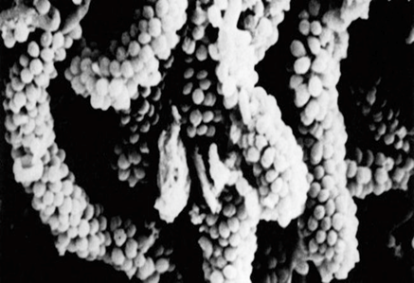

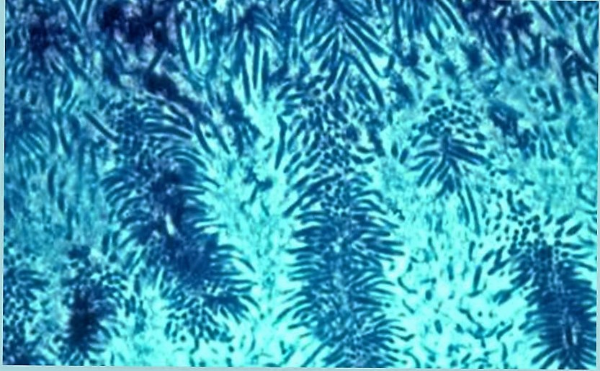

**Test-tube brush” formation**

* Composed of filamentous bacteria to which gram negative rods adhere.

**MICROBIAL SPECIFICITY OF PERIODONTAL DISEASE**

* Non Specific Plaque Hypothesis
* Specific Plaque Hypothesis
* Ecological Plaque Hypothesis
* Keystone pathogenesis hypothesis

**NON SPECIFIC PLAQUE HYPOTHESIS**

* Non specific plaque hypothesis was proposed by WALTER LOESCHE(1976).
* The nonspecific plaque hypothesis maintains that periodontal disease results from the “elaboration of noxious products by the entire plaque flora.”
* According to this ,when small amounts of plaque are present ,the noxious products are neutralized by the host.
* Thus it lead to concept that control of periodontal disease depends on control of the amount of plaque accumulation.

**SPECIFIC PLAQUE HYPOTHESIS:**

* Specific plaque hypothesis states that only certain plaque is pathogenic, and its pathogenicity depends on the presence of or increase in specific microorganisms.

Newman Mg , Socransky Ss (1977)

* Plaque harboring specific bacterial pathogens results in periodontal disease.
* ex:A.actinomycetemcomitansas a pathogen in localized aggressive periodontitis.

**ECOLOGICAL PLAQUE HYPOTHESIS:**

* A change in a key environmental factor (or factors) will trigger a shift in the balance of the resident plaque microflora, and this might predispose a site to disease.

(PD Marsh 1990)

* This hypothesis is based on the theory that the unique local microenvironment influences the composition of the oral microflora.

**Draw back**

* Does not address the role of genetic factors of the host that contribute to the composition of dental plaque and to susceptibility to disease.

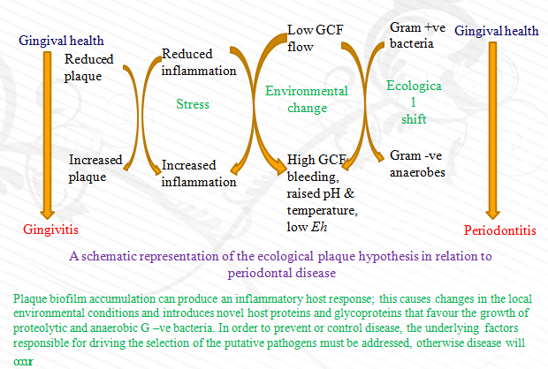

* This hypothesis postulated dynamic relationship between environmental cause & ecological shifts within the biofilm.
* It also introduced the concept that the disease can be prevented not only by inhibiting the putative pathogens, but also interfering with the environmental factors driving the selection & enrichment of these bacteria.

**KEYSTONE PATHOGENESIS HYPOTHESIS**

* *George Hajishengallis* and colleagues stated the concept of (oral) microbiology by proposing “The Keystone-Pathogen Hypothesis”.
* It indicates that certain low-abundance microbial pathogens can cause inflammatory disease by increasing the quantity of the normal microbiota and by changing its composition.
* Porphyromonas gingivalis is shown to be able to manipulate the native immune system of the host (reviewed by Darveau, 2010). By doing so it was hypothesized that it does not only facilitate its own survival and multiplication, but of the entire microbial community.

**MICROBIOME**

* The community of microbial residents in our body is called microbiome
* Oral microbiome, defined as the collective genome of microorganisms that reside in oral cavity.
* The oral cavity has the second largest and diverse microbes after gut harbouring over 700 species of bacteria.
* The mouth with its various niches is an exceptionally complex habitat where microbes colonize the hard surfaces of the teeth and the soft tissues of the oral mucosa.
* An ideal environment is provided by the oral cavity and associated nasopharyngeal regions for the growth of microorganisms.
* The normal temperature of the oral cavity on an average is 37°C without significant changes, which provide bacteria a stable environment to survive.
* Saliva also has a stable pH of 6.5–7, the favourable pH for most species of bacteria. It keeps the bacteria hydrated and also serves as a medium for the transportation of nutrients to microorganisms.

**DEVELOPMENT OF ORAL MICROBIOME**

* Usually oral cavity of new born is sterile.
* At or shortly after birth, colonization begins. Initial colonizers immediately after birth are called the pioneer species.
* The oral cavity is invaded mainly by aerobes by the 1st year and may include *Streptococcus, Lactobacillus, Actinomyces, Neisseria* and *Veillonella*.
* Once tooth eruption begins, these organisms can colonize on the non-shedding surfaces.
* Plaque accumulation is seen at different sites on the tooth such as smooth surfaces and pit and fissures, for different microbial colonies to be established.

**Composition of oral microbiome**

* The microbial ecology of the oral cavity is complex and is a rich biological setting with distinctive niches, which provide a unique environment for the colonization of the microbes.
* The principal bacterial genera found in the healthy oral cavity are as follows

**Gram positive:**

Cocci – *Abiotrophia, Peptostreptococcus, Streptococcus.*

Rods – *Actinomyces, Corynebacterium, Eubacterium, Lactobacillus.*

**Gram negative:**

Cocci – *Moraxella, Neisseria, Veillonella*

Rods – *Campylobacter, Capnocytophaga, Eikenella, Fusobacterium, Hemophilus, Selemonas, Treponema.*

**FUNCTIONS OF ORAL MICROBIOME**

* The oral microbiome usually exists in the form of a biofilm.
* It plays a crucial role in maintaining oral homeostasis, protecting the oral cavity and preventing disease development.
* Understanding the oral microbiome in health and disease will give further directions to explore the functional and metabolic alterations associated states to identify molecular signatures for drug development and targeted therapies which all ultimately help in rendering personalised and precision medicine.

**PLAQUE AS A BIOFILM**

* Biofilm- ‘defined as matrix enclosed bacterial populations adherent to each other and/or to the surfaces or interfaces. (costerton,1995)
* Biofilms consist of one or more communities of microorganisms, embedded in a glycocalyx, that are attached to a solid surface.

**CHARACTERISTICS OF BIOFILM**

**Structure of biofilm**

* Biofilms are composed of micro colonies of bacterial cells (15–20% by volume) that are non-randomly distributed in a matrix or glycocalyx (75–80% volume).
* The bacterial vitality varies throughout the biofilm, with the most viable bacteria present in the central part of plaque , and lining the voids and channels.
* Structure of the Biofilm depends on environmental parameters under which they are formed. These include:
* Surface and interface properties
* Nutrient availability
* Composition of the microbial community
* The biofilm matrix is penetrated by fluid channels that conduct the flow of nutrients, waste products, enzymes, metabolites, and oxygen.
* The bacteria in a biofilm use a communication system termed quorum sensing that involves sending out chemical signals .
* These chemical signals trigger the bacteria to produce potentially harmful proteins and enzymes, virulence factors that help the intraoral biofilm bypass host defense systems.

**EXO POLYSACCHARIDES**

* They act as the backbone of the film
* The bulk of the biofilm consists of the matrix. It is composed predominantly of water and aqueous solutes.
* ‘‘dry’’ material is a mixture of exopolysaccharides, proteins, salts and cell material.
* Exopolysaccharides, which are produced by the bacteria in the biofilm, are the major components of the biofilm, making up 50–95% of the dry weight.

**FUNCTIONS**

* They play a major role in maintaining the integrity of the biofilm aid in protecting microbial cells within the biofilm by preventing desiccation and attack by harmful agents.
* They may also bind essential nutrients such as cations to create a local nutritionally rich environment favouring specific microorganisms.
* The exopolysaccharides matrix could also act as a buffer and assist in retaining extracellular enzymes (and their substrates), enhancing substrate utilization by bacterial cells.

**ATTACHMENT OF BACTERIA**

* The key characteristic of a biofilm - the microcolonies within the biofilm attach to a solid surface.
* Many bacterial species possess surface structures such as fimbriae and fibrils that aid in their attachment to different surfaces.
* Fimbriae have been detected on a number of oral species including

P. gingivalis, A. actinomycetemcomitans and some strains of streptococci.

* Oral species that possess fibrils include S. salivarius, the S. mitis group, Pr. intermedia, Pr. nigrescens, and Streptococcus mutans.

**MICROBIAL INTERACTIONS**

* The residents in the microbial community display extensive interactions while forming biofilm structures, carrying out physiological functions, and inducing microbial pathogenesis.

These interactions, include

* Competition between bacteria for nutrients
* Synergistic interactions which may stimulate the growth or survival of one or more residents
* Production of an antagonist by one resident which inhibits the growth of another
* Neutralization of a virulence factor produced by one organism by another resident
* Interference in the growth-dependent signalling mechanisms of one organism by another.

**GENERAL METABOLIC PRODUCTS WHICH INFLUENCE BIOFILM RESIDENT INTERACTIONS**

* Antagonistic effect - S. sanguinis group are producers of H2O2 , a nonspecific antimicrobial agent- an antagonistic effect on other co-residents, such as S. mutans.
* Synergistic effect - lactic acid produced by S. mutans can be readily metabolized by members of the Veillonella family.
* Co-operative metabolic interactions – F. nucleatum & P. intermedia grow at pH range of 5.0 to 7.0. P. gingivalis susceptible to - pH levels < 6.5.

**BACTERIOCINS**

* Proteinaceous bactericidal substances produced by bacteria to inhibit the growth of closely related bacterial species or strains.
* Regulated by genetic and environmental factors
* Enable bacteria to select their neighbours, promote the establishment of a community with specific bacterial species.
* Inhibition of growth of P.gingivalis,T.forsythia,S.salivarius, S.sanguinis by bacteriocin produced by L.paracaesi
* Nigrescin, produced by P.nigrescens display bactericidal effect against P.gingivalis, P.intermedia, T.forsythia, Actinomyces spp.
* Bacteriocin production also reported by P.intermedia, F.nucleatum, E.corrodens, H.influenzae

**QUORUM SENSING**

* It is defined as the cell density dependent regulation of gene expression in response to soluble signals called autoinducers (Bassler 1999)
* It has been defined by Miller (2001) as “the regulation of gene expression in response to fluctuations in cell population density”.
* Quorum sensing in bacteria , ‘‘involves the regulation of expression of specific genes through the accumulation of signaling compounds that mediate intercellular communication.”- (Prosser 1999)
* This is a method of intercellular communication.
* Quorum sensing depends on cell density.
* Quorum sensing may give biofilms their distinct properties

1. Expression of genes for antibiotic resistance at high cell densities

may provide protection.

2. Has the potential to influence community structure, by encouraging the growth of beneficial species (to the biofilm) and discouraging the growth of competitors.

3. Alteration of physiological properties of bacteria in the community through quorum sensing.

* Several strains of *P. intermedia, T. forsythia, F. nucleatum* and *P. gingivalis* were found to produce quorum sensing signal molecules (Frias *et al*., 2001; Sharma *et al.,* 2005).

**Quorum quenching**

* Quorum quenching refers to the mechanism by which bacterial communication can be interrupted
* It can be achieved by

1)Enzymatic degradation of signalling molecules

2)Blocking signal generation

3)Blocking signal reception

* Inhibitors of quorum sensing can be grouped into two categories
* 1)molecules that structurally mimic quorum sensing signals-these interface with binding of the corresponding signal

ex: halogenated furanones, synthetic auto inducers

* 2)Second, other groups of small enzyme inhibitors

Ex:triclosan ,a potent inhibitor of the enoyl acyl carrier protein(ACP) reductase

* It is gaining importance as a new way to control bacterial biofilms

Shao, H., & Demuth, D. R. (2010).

Periodontology 2000, Vol. 52, 2010, 53–67

**ANTIBIOTIC RESISTANCE**

* Bacteria growing in a biofilm are highly resistant to antibiotics, up to 1,000-1,500 times more resistant than the same bacteria not growing in a biofilm.
* MIC of chlorhexidine and amine fluoride was 300 and 75 times greater respectively, when S.sobrinus was grown in biofilm compared to planktonic cells
* Biofilms of P.gingivalis tolerated 160 times the MIC of metronidazole than planktonic cells
* Bacteria replicate only slowly in an established biofilm and, as a consequence, are inherently less susceptible than faster dividing cells.
* In addition, samples of gingival crevicular fluid (GCF) can contain sufficient ß lactamase to inactivate the concentrations of antibiotic delivered to the site.
* A susceptible pathogen can be rendered resistant if neighbouring, non-pathogenic cells produce a neutralising or drug-degrading enzyme.

**EXCHANGE OF GENETIC INFORMATION**

* The high density of bacterial cells in a biofilm also facilitates the exchange of genetic information among the cells of the same species and across species and even genera.
* Conjugation, transformation and transduction have been shown to occur more easily in a biofilm. Biofilm-associated bacteria communicate with each other by way of horizontal gene transfer.
* Horizontal gene transfer among bacteria is recognized as a major contributor in the molecular evolution of many bacterial genomes.

**DETACHMENT OF CELLS FROM BIOFILMS**

* Can be Movement of Individual cells or Biofilm en masse
* Brading et al have emphasized the importance of physical forces in detachment, stating that the three main processes for detachment are :
  + Erosion or shearing (continuous removal of small portions of the biofilm)
  + Sloughing (rapid and massive removal),
  + Abrasion (detachment due to collision of particles from the of particles of the bulk fluid with the biofilm)

**METHODS OF DETECTION OF DENTAL PLAQUE**

**Use of explorer:**

* Tactile Examination – when calcification has started it appears slightly rough, otherwise it may feel slippery due to coating of soft , slimy plaque.

**Removal of plaque:**

* When no plaque is visible , an explorer can be passed over the tooth surface & when plaque is present it will adhere to explorer tip.
* This technique is used when evaluating plaque index.
* This can be done by running the explorer or probe along the gingival 3rd of the tooth.

**DISCLOSING AGENTS**

* It is a preparation in liquid , tablet or lozenge which contains a dye or other colouring agent. A disclosing agent is used for identification of dental plaque which is otherwise not visible to naked eye .

**THE AGENTS THAT ARE USED AS DISCLOSING AGENTS ARE:**

* Iodine preparation
* Bismark brown
* Erythrosine
* Fast green
* Basic fuchsin

**CONCLUSION**

* Dental plaque biofilm cannot be eliminated permanently.
* However, the pathogenic nature of the dental plaque biofilm can be reduced by reducing the bioburden (total microbial load and different pathogenic isolates within that dental plaque biofilm) and maintaining a normal flora with appropriate oral hygiene methods that include daily brushing, flossing and rinsing with antimicrobial mouth rinses.
* This can result in the prevention or management of the associated sequelae, including the development of periodontal diseases and possibly the impact of periodontal diseases on specific systemic disorders.

**REFERENCES**

* Clinical Periodontology - Carranza (9th & 10th ed)
* Clinical Periodontology- Jan Lindhe, Thorklid Karring , Niklaus P Lang.
* Clinical Periodontology : Listgarten.
* Structure of dental plaque – perio 2000, vol 5, 1994, 52-65.
* Periodontal microbial ecology - Perio 2000,Vol. 38, 2005, 135– 187.
* Dental biofilms: difficult therapeutic targets - Periodontology 2000, Vol. 28, 2002, 12–55.